Title of Paper | Fire Standards Progress Report
Decision or Information | For information
Title and Date of Meeting | LGA Fire Services Management Committee  14th March 2022
Attachments | None

Summary
This paper provides members of the LGA Fire Services Management Committee (FSMC) with a summary of the progress on the professional Fire Standards. The Fire Standards Board last met formerly on 8th December.

Recommendations
Members are asked to:
- note the contents of this report for information;
- provide ongoing support to officers in enabling and empowering them to engage in the development and implementation of the Fire Standards both in production and when published; and
- encourage the monitoring of the benefits of the Fire Standards in their services.

Current Status
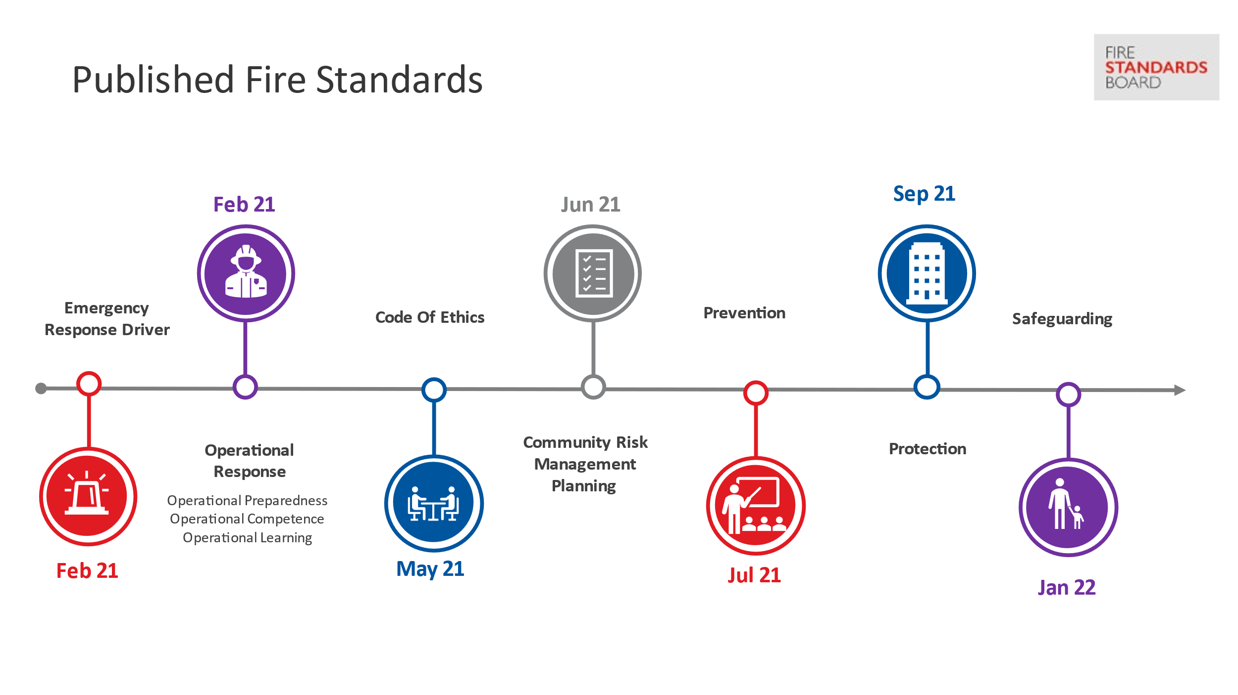
There are now nine published Fire Standards which are available on the Fire Standards Board (FSB) website and shown in the timeline figure below. The latest standard launched was Safeguarding in January.

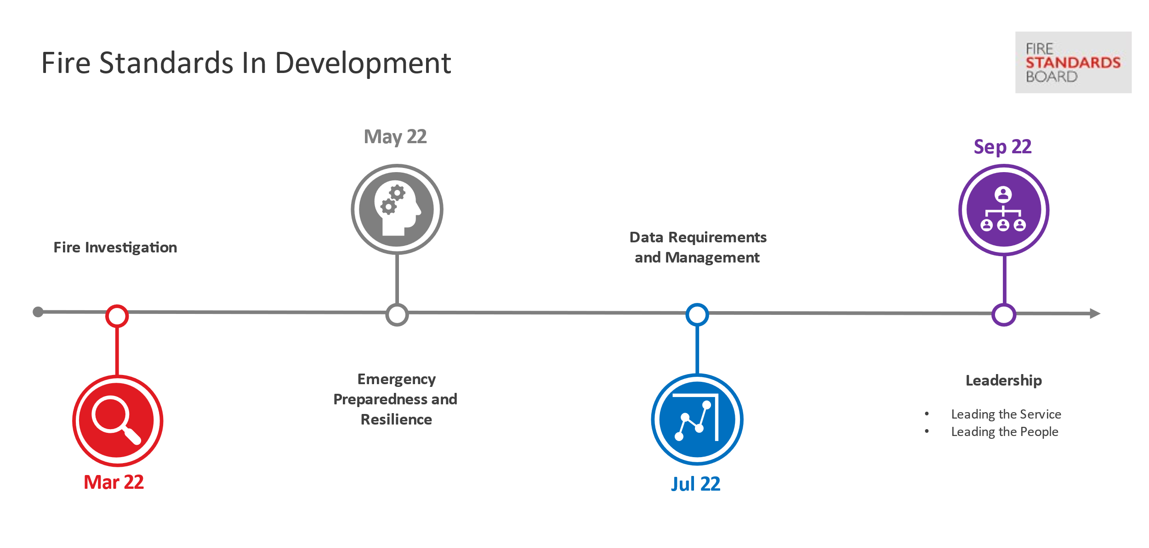
A second phase of Fire Standards development is underway, shown on the timeline diagram below, followed by a summary of the current status by standard:

Development Update
Fire Investigation
- Consultation on this standard completed in December 2021.
- Analysis of results has taken place and minor amendments made to the version presented to Board in December which was signed-off to commence QA.
- QA was completed and the Board has since approved the Fire Standard for publication.
- Expected publication by the end of March 2022.
Emergency Preparedness and Resilience
- A draft standard was produced in October and a peer review on the draft standard took place in November.
- Following peer review the change of name from Emergency Planning to Emergency Preparedness was agreed. The rationale for this was that planning was one element of emergency preparedness.
- Consultation on this standard completed in February 2022.
- Expected publication by May 2022.
Data Requirements and Management
- An early draft standard has been produced and peer review has been completed.
- Consultation is scheduled to commence in March 2022.
- Expected publication by July 2022.

Leadership Fire Standards
- Development work started initially based on three Fire Standards. Following feedback in January 2022, these Fire Standards have evolved again and been consolidated into two Fire Standards.
- The Two Fire Standards will cover the following;
  - Service Leadership (formerly “well-led” organisation) – setting out what an organisation that is well-led would look like and expectations of operational leaders and their behaviours
  - Service Management – setting out what an organisation who looks after and supports its people and workforce looks like
- Following the progress report provided to the FSB at its December 2021 meeting, both the LGA and APCC have been provided the opportunity to comment on the standards in their early stage of development.
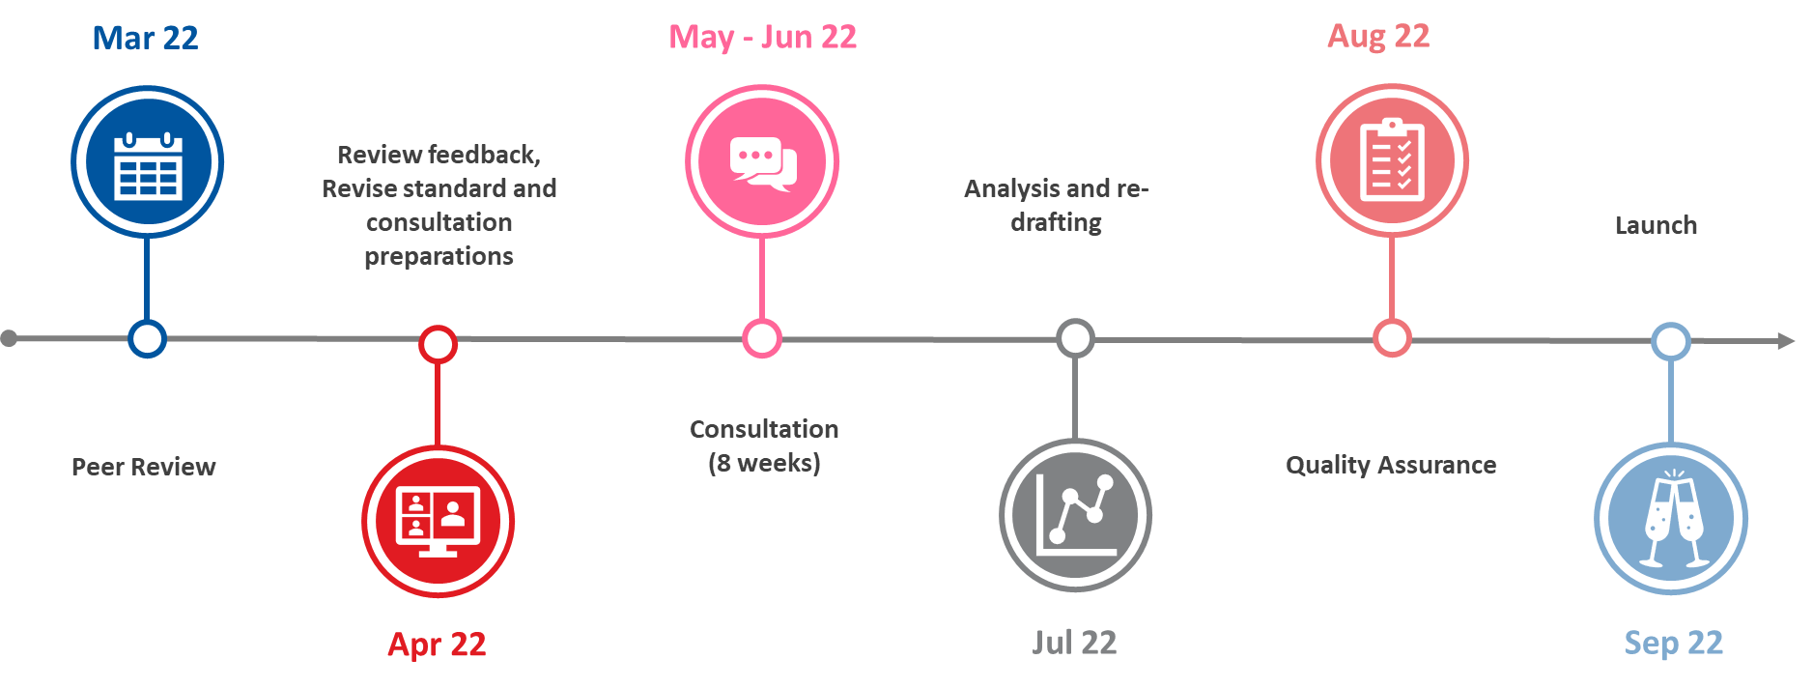
- It has been acknowledged that given the nature, breadth and importance of these Fire Standards, more time has been allowed for both peer review and consultation and a new timeline has been developed which is shown below:
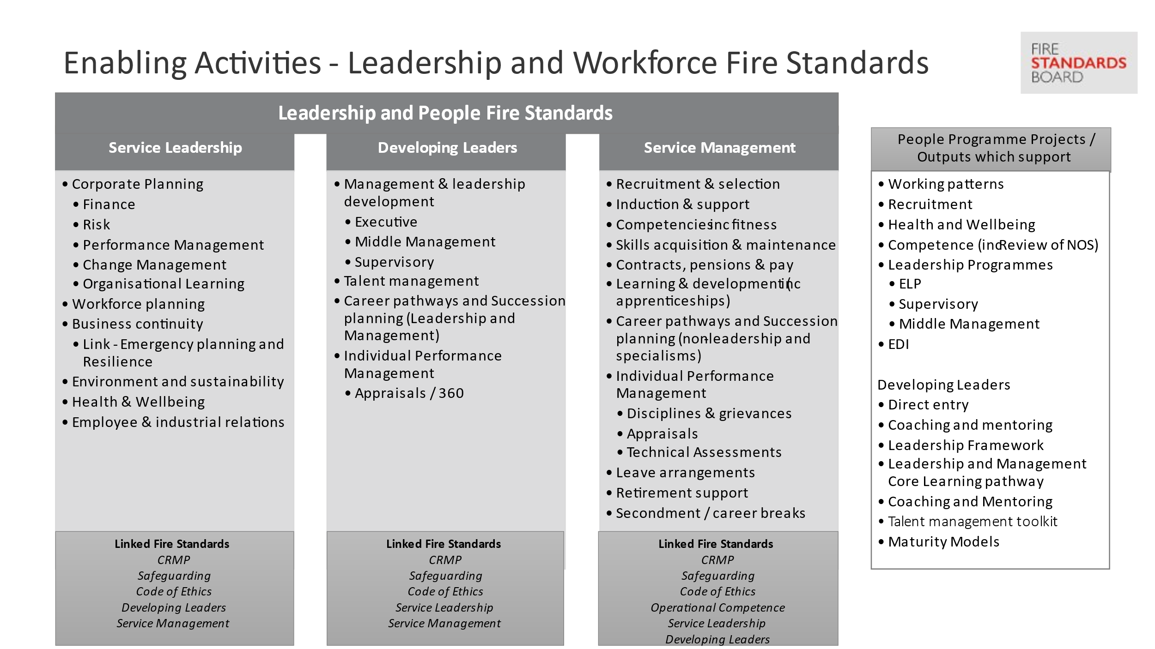
- For background, the original scope of the Leadership and People Fire Standards is shown in the figure below:

Remaining Areas for Consideration
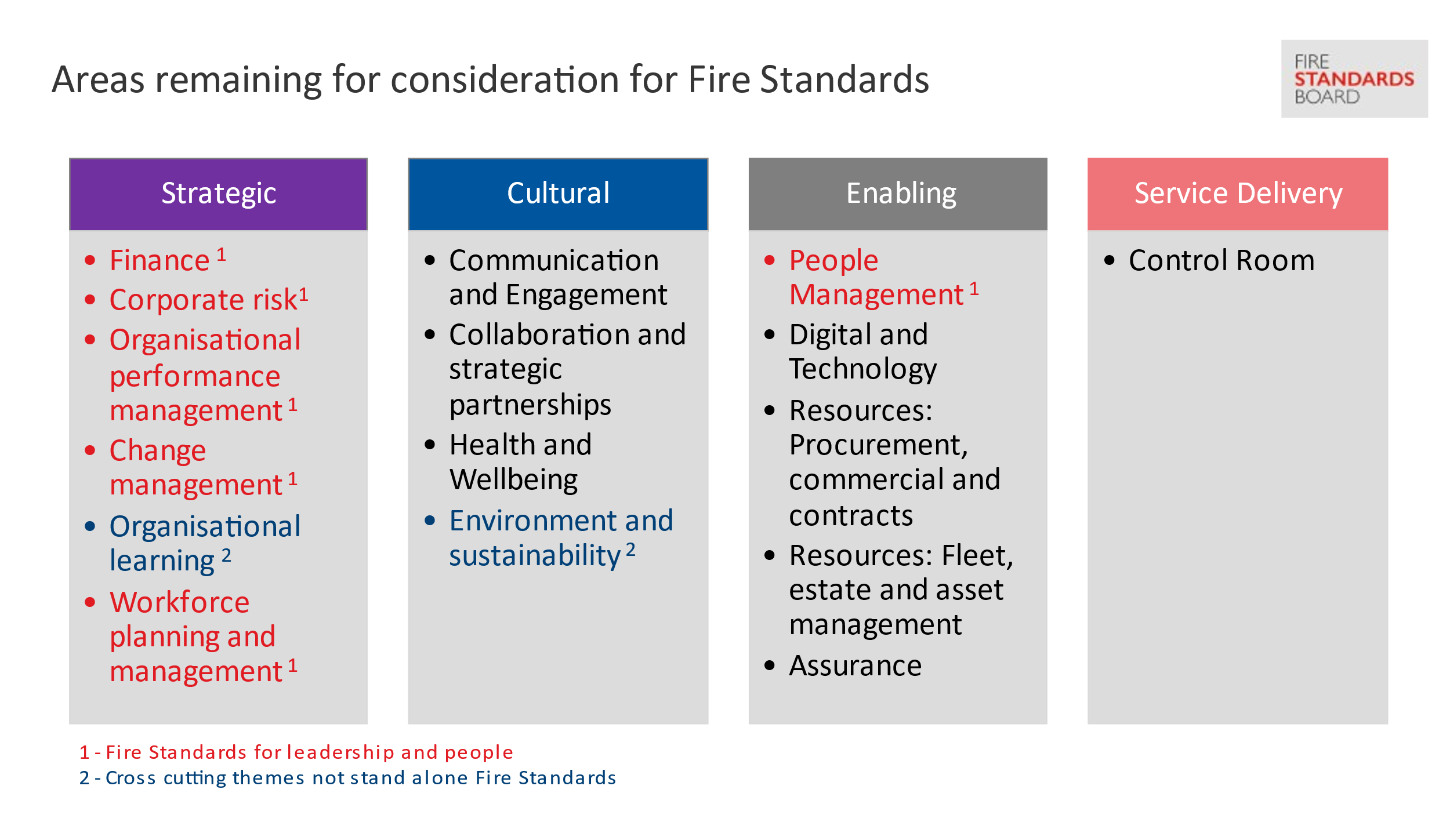
The figure below shows the remaining areas for consideration for possible Fire Standards.

It will not necessarily follow that a single Fire Standard will be developed for each activity listed above, but these are the areas of activity that remain outstanding. Discovery work and research in each area will help clarify and confirm what standards may be developed in a third phase. Proposals will be made to the FSB in April 2022.
It is anticipated that the full suite of standards will total approximately 20.
The FSB has a defined periodic review process in place following publication of a Fire Standard but can initiate an exceptional review should the need arise.

Implementation support
The FSB, through the NFCC Fire Standards and Implementation Teams, will be continuing to support services as they work to achieve the Fire Standards. Implementation tools are provided with all published Fire Standards.

Impact and Benefits Realisation
The FSB are keen to understand the impact of the Fire Standards now that the first standards have been published. As part of both the development process and the consultation on each Fire Standard we ask services about potential impacts.
The FSB will be undertaking engagement activity with services during the summer 2022 to help better understand impacts and review progress to date.

Background notes for information
The Fire Standards Board (FSB) is responsible for the identification, organisation, development and maintenance of professional standards for fire and rescue services in England. Led by an independent Chair and Vice Chair, membership of the Board includes the NFCC, employers (both the LGA and the APCC) and the Home Office.
The LGA representative on the Board is Cllr Nick Chard.
The FSB continues to meet regularly to review the progress made on Fire Standards development. Its next meeting is scheduled for 4 April 2022.
Given the various stages of development required and the time needed for engagement with services in the early stages as well as through formal consultation, development work and publications are staggered. This is primarily done to align capacity and resources in a considered way, but also to pace the rate at which standards are released to services.
Once approved, Fire Standards are shared on the Fire Standards Board website.
Services should now be aware of the requirements being placed upon them through these Fire Standards. Her Majesty’s Inspectorate of Constabulary and Fire and Rescue Services (HIMCFRS) will be referencing the standards in their inspection arrangements and therefore services should be prepared to evidence their progress towards achieving them.
The Fire Standards Board would welcome and appreciate the support of fire authority chairs and members in:
- ensuring their services are enabled to engage in Fire Standards by releasing their subject matter experts to support development work and peer review through the NFCC where appropriate and feasible.
- respond to the Fire Standards consultations as they are published; and,
- support activities to achieve those Fire Standards through implementation once approved and published.

